AWS AND DPC connectivity.

1]. Create an AWS account in aws.amazon.com
2]. After successful account creation and activation, you can use the AWS service.
3]. Go to the Console home and search for S3 (Simple Storage Service) and click on it.
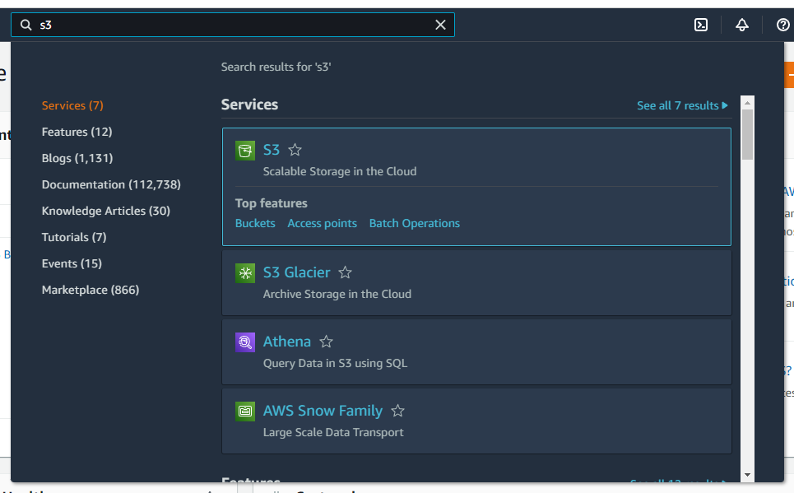

4]. Create S3 bucket
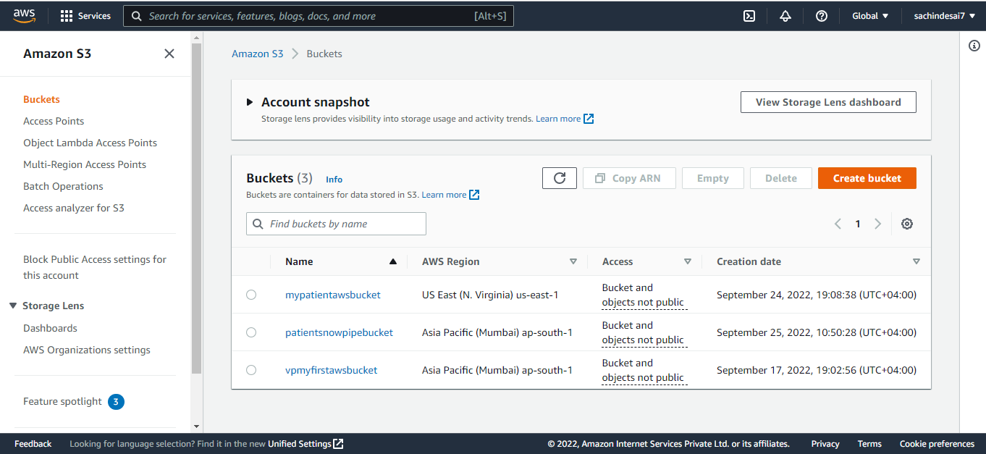

5]. Create a folder inside the bucket ( e.g. snowpipe)
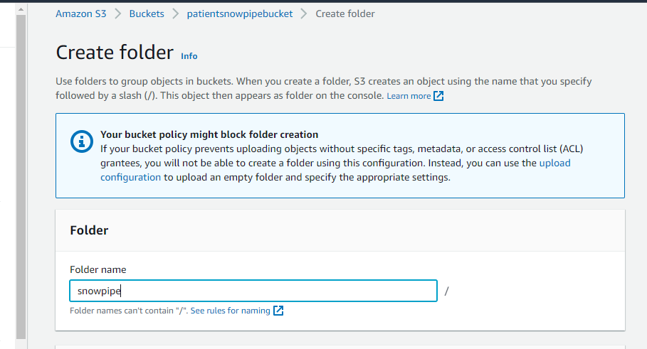

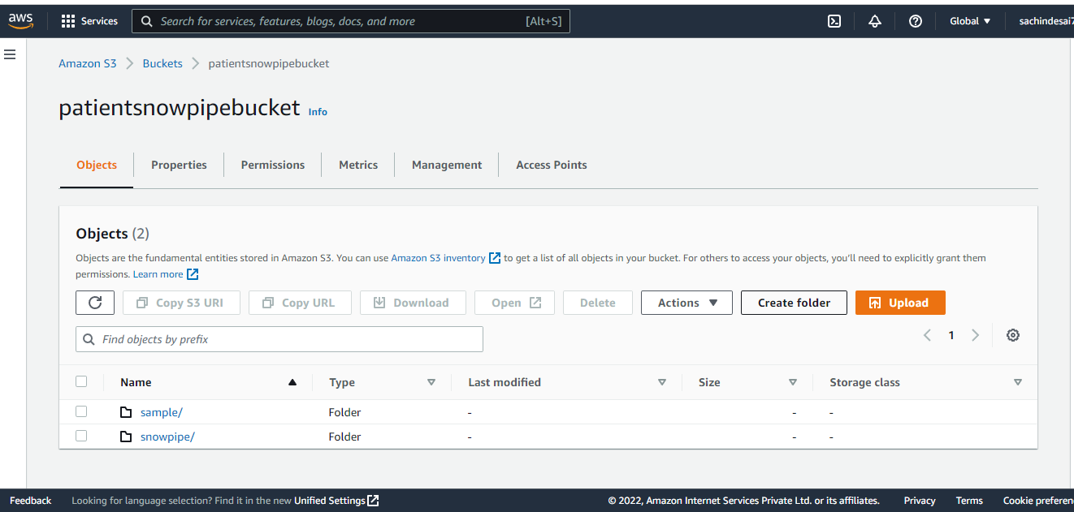

6]. Once the S3 bucket and folder are created, Click on your name and select Security credentials .

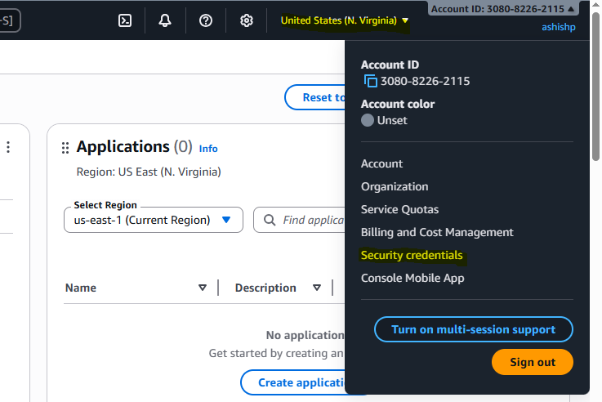

7]. Go to Access key.

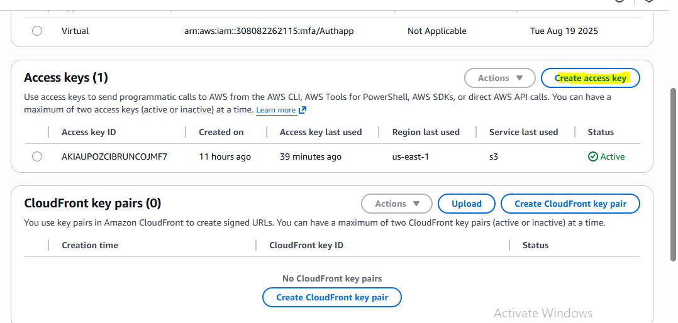

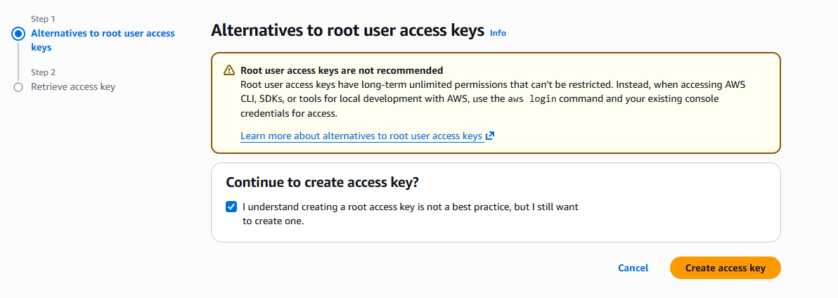

9.Copy paste the ACCESS KEY AND Secret key in DPC

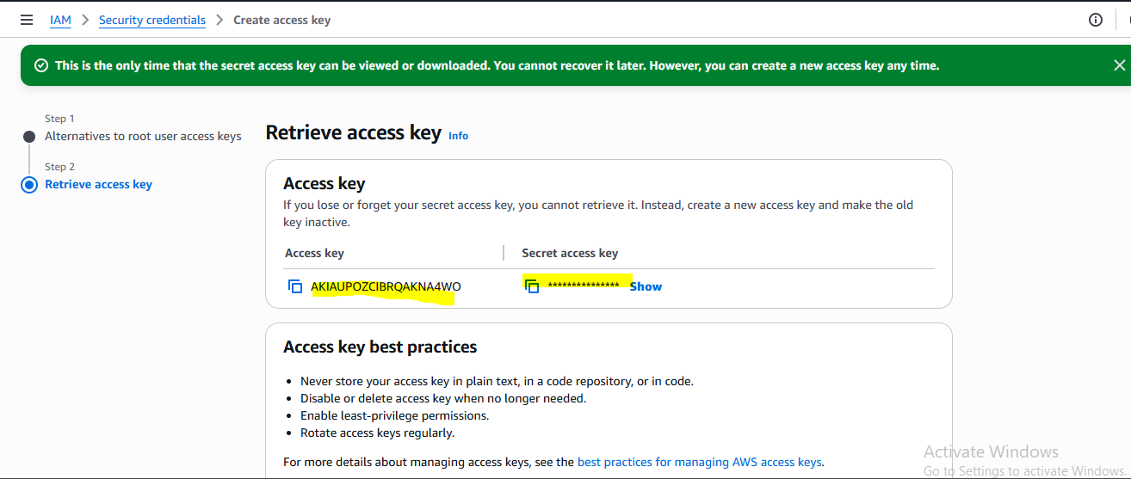

10.Go to more option for cloud.

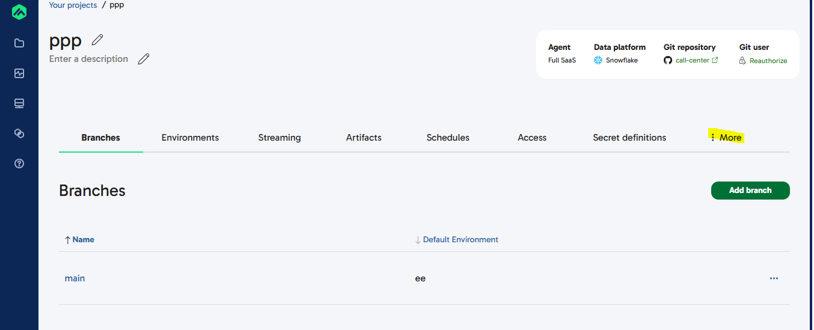

11.Select your cloud here we are going for Aws.Copy paste credential from secret access key.

